Project Design Phase-II
Technology Stack (Architecture & Stack)

Date | 05-Oct-2026
Team ID | SWTID-2026-4623
Project Name | AI BlogNest API
Maximum Marks

Technical Architecture:
The Deliverable shall include the architectural diagram as below and the information as per the table1 & table 2
Architecture of AI BlogNest API (layered MVC backend with AI integration):
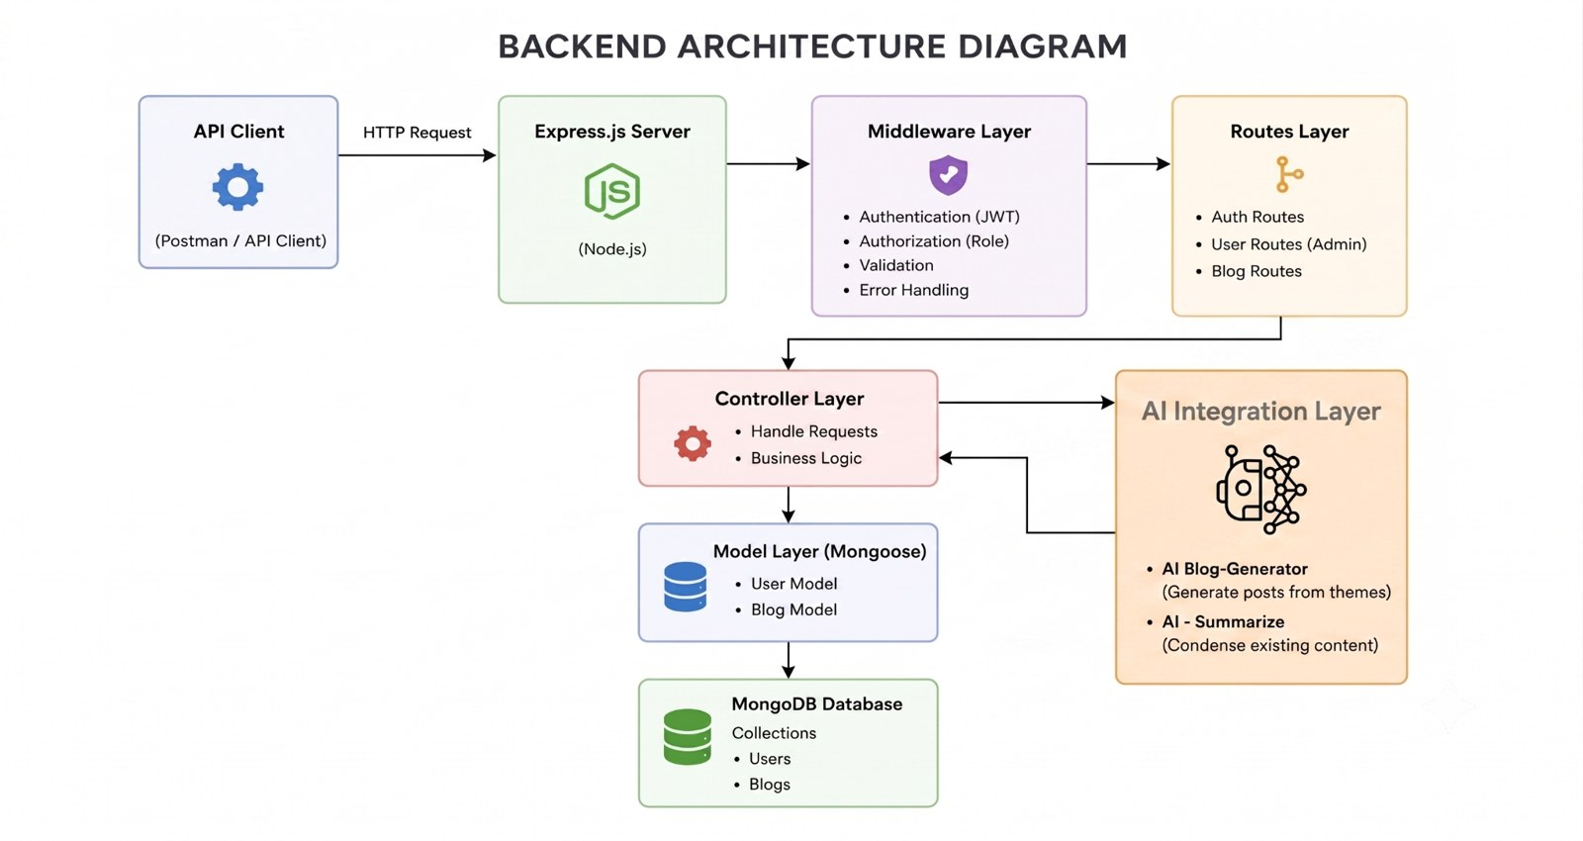

Table-1 : Components & Technologies:
S.No | Component | Description | Technology
 | User Interface | Headless backend - clients such as Postman / ThunderClient call REST endpoints and receive JSON | Postman, ThunderClient (API client)
 | Application Logic-1 | Authentication & authorization: registration, login, JWT validation, role checks (Admin, Editor, Author, Reader) | Node.js, Express.js, JWT, bcrypt.js
 | Application Logic-2 | Blog, category / tag, comment and media-path management using Controller and Routes layers (MVC) | Express.js controllers & routes
 | Application Logic-3 | AI integration layer: AI Blog-Generator (/api/ai/generate-blog) and AI Summarize (/api/ai/summarize) | Node.js service calling Gemini API
 | Database | NoSQL document database with collections for users, posts and comments | MongoDB, Mongoose ODM
 | Cloud Database | Not required for the current build; a hosted database can be used when deployed online | MongoDB Atlas (optional)
 | File Storage | Media path / metadata is stored with the post in the database; files kept in local file system | Local file system
 | External API-1 | Generate high-quality blog content from a topic | Google Gemini AI API
 | External API-2 | Summarize long content; also used for AI FAQ assistance, WeatherWise and FitTrack insights | Google Gemini AI API
 | Machine Learning Model | Generative large language model for blog generation and summarization (used through API, not trained locally) | Google Gemini (LLM)
 | Infrastructure (Server / Cloud) | Local server: Windows 10/11, macOS or Linux; Intel i5 (8th Gen) / Ryzen 5, 8 GB RAM (16 GB recommended), 1 GB disk  Cloud deployment can be added later | Local (Node.js v16+, npm v8+)

Table-2: Application Characteristics:
S.No | Characteristics | Description | Technology
 | Open-Source Frameworks | Open-source frameworks and libraries used to build the API | Node.js, Express.js, Mongoose, MongoDB, bcrypt.js, JSON Web Token (JWT)
 | Security Implementations | JWT authentication, role-based access control, password hashing, request validation, input sanitization (XSS / NoSQL injection), rate limiting, CORS, centralized error handling | JWT, bcrypt.js, RBAC middleware, OWASP-aligned practices
 | Scalable Architecture | Layered MVC design (routes, controllers, models) with stateless authentication, so the API can scale horizontally and new modules can be added easily | Node.js, Express.js, MongoDB
 | Availability | Stateless API instances can run behind a load balancer; database replication can be enabled for failover | Load balancer, MongoDB replica set (deployment option)
 | Performance | Non-blocking Node.js I/O, indexed Mongoose queries, lightweight JSON responses; caching or CDN can be added for media and popular posts | Node.js, Mongoose indexing

